

Your Community Connection

**April**

Community Update

**Local Market Update**



SOLD DOLLAR VOLUME

**$21.98m**

HOMES FOR SALE

**138**



AVERAGE SALE PRICE

**$274.703**

CLOSED SALES

**79**



MEDIAN DAYS ON MARKET

**69**

**In this issue:**

Sprouts and Aldis to Come to Mesa Mesa Adventure Challenge Free Workshops

Local Market Update





April 2019 | Volume 19 | Issue 4



**Sprouts and Aldi’s Coming to Southeast Mesa**

Two popular grocery retailers are soon arriving in our neighborhood

Sprouts Farmer’s Market announced that is will open their new store on June 5 at 1240 S Signal Butte on the SW corner of Southern and Signal Butte. Sprouts will anchor the new Mountain Vista Marketplace.

Sprouts is having a hiring event April 24 and 25, where they intend to hire 140 full and part-time employees including managers, clerks, receivers, and more.

Sprouts, known for its fresh, natural, and organic products, also offers bulk foods, vitamins, and supplements.

Aldi’s, a German chain that is expanding heavily across the United States, will be opening their new Mesa store on the Northeast corner of Guadalupe and Signal Butte in 2020.

Aldi’s, a German chain that is expanding heavily across the United States, will be

Aldi’s considers themselves to be a disruptor in the supermarket industry and seeks to become the third largest grocer in the U.S. behind Walmart and Kroger (who

operates as Fry’s in Arizona.) They are currently ranked 15th in the nation,

Aldi’s also is the parent company of the specialty grocer Trader Joe’s.

The grocery competition is ramping up in Southeast Mesa with the relatively-new Fry’s at Signal Butte and Guadalupe, the new Safeway in Eastmark having broken ground, and these additional players to reach the growing population of 85212 and 85209.

Aldi’s is known as being a no- frills discount chain that sells its own branded food. They boast that the brands are made by the country’s leading food producers and have the same or higher quality as national name brands.

Grocery customers bag their own groceries and rent carts by depositing a quarter and regaining their deposit by returning the cart. Curstomers also either bring their own bags or buy reusable ones at checkout.

Aldi’s also keeps limited hours of operation and only a few employees working in a store at any given time.

**2** SEARCH THE MLS FOR FREE AT KLAUSTEAM.COM



Staying Active:

**Gather your family for the Mesa Adventure Challenge: Bike Edition!**

The Mesa Adventure Challenge Bike Edition is a family-fun adventure that is as much adventure race as it is scavenger

hunt.Compared to The Amazing Race, but on a local level, where anyone over the age of 12 can participate. The scavenger hunt is all about having a good time!

The event consists of teams of two to six people that will solve clues, travel to local points of interest, and complete fun challenges while discovering Mesa in a whole new way on bicycles. The course is around 2-4 miles long and will take about 1.5 hours to complete. Teams must use bicyles only!

The event is being held on Saturday, April 6, 2019 at Rendezvous Park, 263 N Center Street, in Mesa.

The event begins at 10:30am and is officially over at 12:00pm.

Race check-in 9:30am with Mandatory pre-event meeting to follow at 10:15am.

Parking suggestions include the dirt lot on 2nd St and Pasadena, just east of the Marriott, and the convention center parking lot west of the hotel.

So, if you are looking for a fun, adventure and making great memories, this is the event for you! For all the details and registration click here www.mesaaz.gov/ things-to-do/mesa-adventure-challenge.

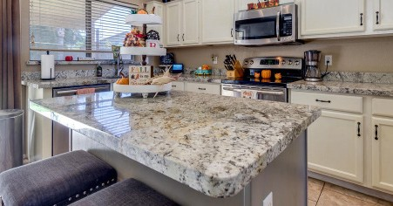

**MY EXPERIENCE HAS BEEN AMAZING!!! CHOOSING THE KENNY KLAUS TEAM WAS THE BEST DECISION IN FINDING THE RIGHT HOME FOR MY DAUGHTER AND I. THEY HELPED ME CLOSE ON MY HOME IN 3 WEEKS AND WAS WITH ME EVERY STEP OF THE WAY. THEY TRULY CAREABOUT YOU AND YOUR FAMILY.**

**I RECOMMEND KENNY KLAUS TO EVERYONE IN FINDING THE RIGHT HOME FOR YOU! :)**

Melissa on Zillow

**WHAT’S MY HOME WORTH? HOMEVALUEREQUEST.COM 3**

ZILLOW.85209.COM

Marketing

YOUR **HOME**

GETTING THE MOST FOR YOUR HOME WHEN RESELLING

Not only were minor changes made to the property, but the photographs prepared by the Klaus Team were brighter and more vivid.

“Seven days after we listed the home, it sold for $20,000 more than it had been listed by the previous agent,” Kraig told us.

**Make Sure the Home is Marketed Everywhere Buyers Are**

Even real estate marketing experts aren’t sure where a buyer will find the home they choose to purchase. Sometimes their realtor may find it for them, they may find it on a major search portal, or they may find it on a site you’ve never heard of before.

“We’re not sure what site your buyer will search,” said Kenny Klaus. “That’s why we keep all of the bases covered. Pretty much anywhere on the web that someone can search for real estate, your property will be there.”

Two popular grocery retailers are soon arriving in our neighborhood

**Present the Home Effectively**

When putting your home on the market, you want to make sure that your home not only looks the best it can, but that it is seen in the best light.

Cleaning your home and reducing clutter will help potential buyers see more opportunity for the property’s livability. Taking the time to pack up some of your decor and items will make a big difference not only in how your home photographs, but also in your showings.

The visual representation of your home is vitally important. “The first showing is no longer through the front door,” said East Mesa expert Kenny Klaus. “With the expansion of viewing properties online, the first showing is now on the Internet, so we have to make sure homes look as good as they can when listing them.”

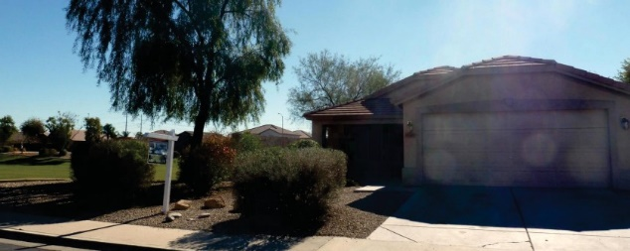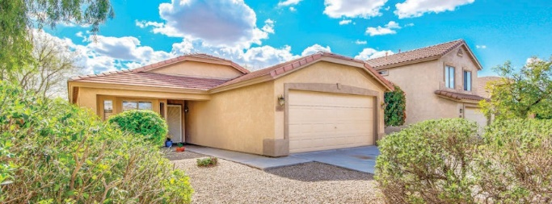

This home sold for $20,000 more within 2 weeks after minor cosmetic changes and due to The Klaus Team’s marketing systems.



**WORKSHOPS**

***Free* APRIL**

HOME BUYING & SELLING

**WORKSHOP**

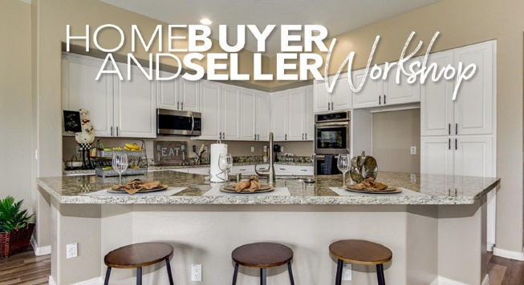



* Two popular grocery retailers are soon arriving in our neighborhood
* How to get the most money for your home
* How to get the most money for your home
* How to get the most money for your home
* Two popular grocery retailers are soon arriving in our neighborhood
* How to get the most money for your home
* How to get the most money for your home
* How to get the most money for your home

Including how the buying and selling processes have changed in the past few years

**Thursday, June 13**

**6:03 PM**

**Saturday, June 15**

**9:32 AM**

**FREE DOWNLOADS!**

Attendees will receive some valuable savings by attending.

**Register today at**

**klausteam.com/workshops**



Klaus Team Training Room

2919 S Ellsworth Rd #133 | Mesa AZ





**1.2**

**MO SUPPLY**

Last Year: 1.9

**MONTHS OF INVENTORY**

**SUPERSTITION SPRINGS**

7451 E Naranja Ave | 1,099 Sqft | $254,900 7533 E Nido Ave | 1,500 Sqft | $265,000 7526 E Medina Ave | 1,544 Sqft | $275,000 7524 E Milagro Ave | 2,169 Sqft | $315,000 7247 E Kiva Ave | 2,053 Sqft | $323,000

7519 E Kiowa Ave | 2,051 Sqft | $337,000 7430 E Kilarea Ave | 2,051 Sqft | $374,000

**AUGUSTA RANCH**

2743 S Keene Ave | 1,505 Sqft | $279,900

2344 S Bernard | 1,530 Sqft | $289,900 9623 E Monterey Ave | 1,970 Sqft | $345,000 2203 S Keene | 2,362 Sqft | $358,900

9523 E Monte Ave | 2,833 Sqft | $385,000 9742 E Navarro Ave | 3,367 Sqft | $419,000 9708 E Navarro Ave | 2,438 Sqft | $422,000

**SIERRA RANCH**

9729 E Jan Ave | 2,036 Sqft | $299,000

1660 S Aaron St | 1,872 Sqft | $320,000 1910 S Rialto Ave | 2,704 Sqft | $350,000 9658 E Irwin Ave | 2,980 Sqft | $385,000

**CRISMON CREEK**

10042 E Isleta Ave | 1,479 Sqft | $247,000

10314 E Idaho Ave | 2,689 Sqft | $349,900

10413 E Irwin Cir | 2,393 Sqft | $387,500

10337 E Irwin Cir | 2,506 Sqft | $394,990

**VILLAGES OF EASTRIDGE**

10108 E Lomita Ave | 2,470 Sqft | $370,000

10431 E Kiva Ave | 3,075 Sqft | $375,000

10465 E Lomita Ave | 2,281 Sqft | $378,500

10613 E Medina Ave | 3,826 Sqft | $439,900

These listings are only a sample of recent sales in the area and were taken from ARMLS as of 11/5/19. If your home is listed for sale with another broker, this is not intended as a solicitation of business.

**RECENT SALES**

**85209**

**6**

**9**

**1**

**BUYER’S MARKET**

**SELLER’S**

**MARKET**



Get a free valuation and instant offers at

**KlausTeam.com/sell**

MULTIPLE SELLING SOLUTIONS | FLEXIBLE COMMISSIONS | LOCAL EXPERTS

**Call us today at 480.354.7344**

**AVERAGE PRICE FOR**

**SINGLE FAMILY DETACHED HOMES**

**$369,172**

Last Year: $342,168

**SINGLE-FAMILY HOMES SOLD**

**85**

Last Year: 72

**Get Your Home Sold!**

**Multiple Offers On Your Home with no obligation!**

**Call us today at 480.354.7344**

**MEDIAN NUMBER OF DAYS HOMES SPENT ON THE MARKET**

24

Last Year: 26



**Connect** with other local business owners and **grow**!

**Neighborhood Networking Meeting**

Come **join** other motivated area businesspeople and introduce your business, **share** your best practices, **discuss** effective marketing tools, **learn**, and **expand** your referral base.

**There is no cost to this event.**

Your Community Connection Neighborhood Networking Meetings are held at **The Hub Grill and Bar** at **1925 S Sossaman** every **third Tuesday** morning from **7:30am-8:45am**.

For more information, call **480.354.7344**. Every local businessperson is invited, no matter the size of the business.

**You*’*re invited to our next meeting, April 16 at 7:30am!**



**LET THE POWER OF OUR TEAM WORK FOR YOU**

**We Will Work with Your Real Estate Professional to Help You STAND OUT and Get You And Your Family Home FASTER.**







**CALL (480) 215-5590 TO LEARN ABOUT YOUR HOME FINANCING OPTIONS**



**WE WORK WITH FAMILIES, NOT FILES.**



**WHAT’S MY HOME WORTH? HOMEVALUEREQUEST.COM 7**

**Call Today 480.354.7344**

MULTIPLE SELLING SOLUTIONS | FLEXIBLE COMMISSIONS | LOCAL EXPERTS

Get a free valuation and instant offers at

**KlausTeam.com/sell**

It’s easy to discover all of your possibilities, including instant offers and traditional retail.

All of your solutions are in one place so you can compare them side-by-side.

No matter how you choose to move, we’re here to be your guide.

**Know all your options and get** **multiple offers before you list.**

**It’s almost 2020. There’s more than one way to sell your home. We know them all.**

**We’re not a one-trick pony.**

**CITY, . XXX**

**ERMIT NO**

**P**

**US POSTAGE**

**YOUR PAID STATE**

**PRESORT STD**

**Postal Customer ECR WSS**

